User Manual – Othello/Reversi
Author: Kirit Bhatti
Version: 1.0.0
Last updated: 7.12.25
Host link: http://127.0.0.1:5000
License: This project is licensed under the MIT license – see the LICENSE file for details.

1 Introduction
The game is a web-based Othello game that allows for a human player and an AI player, on an 8x8 board, with 64 double-sided counters. (dark on one side, light on the other) The AI opponent is the light counter, and you will be the dark counter that takes their go first. Once you have taken your turn, the AI opponent will automatically take a turn.
The aim of the game is to have the most counters on the board by strategically placing counters to “outflank” and flip the opponents’ counters, according to Othello rules.
The game ends when there are no legal moves left for either player, or the move counter (initially set to 60) reaches 0.
The game logic is separate from the way it is displayed to the user.

2 Installation / Setup
This game needs both Python and Flask installed. To do this, open your terminal and input “pip install python”. If it has been installed correctly, the terminal should output “Download successful”; it will say it already exists if it has already been downloaded.
To install Flask, input “pip install Flask”, and it should give a similar result as when Python was installed.

3 Game rules
Initially, there will be four counters in the centre of the board. Two of these will be light, and two will be dark.
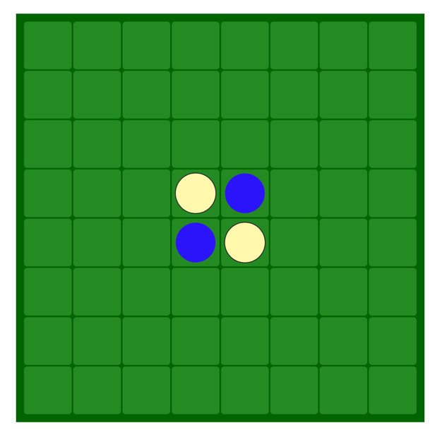
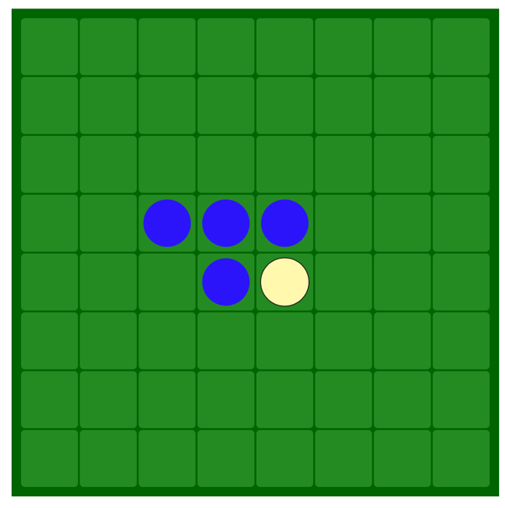
A legal move is when a counter is placed to surround the opponent’s counter on each end. This will flip the opponent’s counter to your colour. As shown below, a dark counter has been placed in square 3, 4 (3 from the top and 4 down). This counter surrounds the light counter at 4, 4. This causes this counter to flip to dark as it has been outflanked.

4 Running the Game
Since files are in different folders, the code in the ‘flask_game_engine_ai.py’ file needs to be changed so that the path to imported files matches those on your computer. Currently, this is what the code looks like: sys.path.append("/Users/kiritbhatti/Downloads/programming_coursework_2/Stage 1")
You need to change the path in the quotation marks to the path to the file on your computer.
To run the game, input ‘cd “path to Stage 3 folder”’. Then, input ‘python flask_game_engine_ai.py’, which is the name of the file that runs the game. Terminal should then output the web address ‘http://127.0.0.1:5000/’. Open your browser and go to the address. This should load to the board.
To take your turn, click on a space where the move is legal, according to the rules given in section 3. This should cause counters to flip to your colour. The game log, at the bottom of the page, will update with whose turn it is and where the counter has been placed. It will also tell you if you have made an illegal move. If you have, try placing your counter somewhere legal. The AI opponent will then take their move.
Please click anywhere on the board once the game has ended, and the board is full, to reveal the winner.
The web page also has save and load buttons above the game log. When the save button is pressed, the current state of the game board will be saved to a JSON file. To load this later, press the load button. The web page will then refresh to show the board that was saved earlier.

5 API usage
This game uses Flask to display the board to the user. Each route used has been defined below.
Home route
First, a route is created to open an HTML template that displays the Othello board and game log.
Move route
A route is then created to handle a user’s move using the GET method. It takes an x coordinate (column number) and a y coordinate (row number) where the user wants to place their counter. It responds with the updated game board, the next player and the status of the game.
AI move route
This route handles the AI opponent’s move. It selects a legal move and returns the updated game board and state.
Save game route
This saves the current game board in a JSON file.
Load game route
This loads the most recently saved game state in the JSON file to the web page.

6 Common issues
If Flask doesn’t run correctly, check that you have installed it correctly. If you have, try repeating the steps in section 4 to run the game.
An illegal move occurs when outflanking isn’t possible in the position chosen. The game log will output “invalid move”, prompting you to try again.
When the game nears the end, the board will fill up, causing there to be no legal moves left. This will be output in the game log, and the winner will be revealed.

7 Appendix
Testing has been carried out using pytest to ensure that the game functions smoothly. I carried out tests on individual files and subroutines. Below is a table of all the tests carried out and their results.
Function being tested | Test description | Code | Expected result | Actual result
Initialise_board | This test has been carried out to check that the size of the board created is 8 by 8. | def test_board_size():  # Check there are 8 rows  assert len(board) == 8  # Check there are 8 spaces in each row  for row in board:  assert len(row) == 8 | The board is of size 8. | PASS
Initialise_board | This test checks if there are 2 light counters and 2 dark counters in the correct positions in the centre of the board. | def test_initial_counters():  assert board[3][3] == 'Light'  assert board[3][4] == 'Dark '  assert board[4][3] == 'Dark '  assert board[4][4] == 'Light' | 4 counters placed in the centre (2 dark, 2 light). | PASS
Legal_move | This test checks if the legal_move function returns True when a legal move is input. | def test_legal_move_identified():  # Check if a dark counter placed at (3,4) is legal  assert legal_move('Dark ', (3,4), board) == True | It should return True as (3,4) is a legal move. | PASS
Legal_move | This test checks if the legal move function returns False when an illegal move is input. | def test_illegal_move_identified():  # Check if a dark counter places at (1,1) is legal  assert legal_move('Dark ', (1,1), board) == False | It should return False as (1,1) is an illegal move. | PASS
Check_moves_available | This test checks if both colours have legal moves available at the start of the game. | def test_moves_available():  assert check_moves_available('Dark ', board) == True  assert check_moves_available('Light', board) == True | It should return True in both cases as both counters always have legal moves available at the start | PASS
Flip_counters | This test checks if counters are flipped correctly, when a legal move occurs. | def test_flip_counters():  assert legal_move('Dark ', (3,4), board) == True  flip_counters('Dark ', (3,4), board)  assert board[2][3] == 'Dark ' | The board should update with flipped dark counters. | PASS
Check_moves_available | This test checks if the function returns False when there are no legal moves available for a player. | def test_no_legal_moves():  # Fill the board with dark counters  for i in range(8):  for j in range(8):  board[i][j] = 'Dark '  # Place a None counter in the top corner  board[0][0] = 'None '  assert check_moves_available('Light', board) == False | The board should be filled with dark counters so there should be no legal moves for the light counter. | PASS
find_legal_moves | This test checks if the AI opponent returns a legal move. | def test_legal_ai_move():  ai_coords = find_legal_moves(board)  assert legal_move('Light', ai_coords, board) == True | The AI opponent should return a legal move. | PASS
Flip_counters | This test checks if the AI opponent flips counters correctly. | def test_ai_flips():  ai_coords = find_legal_moves(board)  # Flip counters according the AI move  flip_counters('Light', ai_coords, board)  dark_count = 0  light_count = 0  # Count the number of each colour  for row in board:  for counter in row:  if counter == 'Dark ':  dark_count += 1  elif counter == 'Light':  light_count += 1  # The AI opponent should have more than 2 counters to show flipping  assert light_count > 2 | The number of light counters should be greater than 2. | PASS
Flask home route | This test checks that the webpage loads correctly with the title Othello. | def test_webpage_loading(client):  response = client.get('/')  # Ensure the webpage loads correctly  assert response.status_code == 200  # Check the word Othello, in bytes, is on the webpage  assert b'Othello' in response.data | The webpage should load correctly with the title Othello. | PASS
Flask move route | This test checks if the move route works correctly, when a legal move occurs. | def test_move_route_valid(client):  # Coordinates for a known legal move on initial board  response = client.get('/move', query_string={'x': 3, 'y': 4})  data = json.loads(response.data)  assert data['status'] in ['success', 'game_over']  assert 'board' in data | It should return success. | PASS
Flask save game route | This test checks that the game has been saved correctly. | def test_save_game(client):  # Set the game state  game_state = {"board": board, "current_player":'Dark ', "move_counters": {}}  # Put the game state in the json file  response = client.post('/save_game', data=json.dumps(game_state), content_type='application/json')  # Check the game has been saved  assert response.status_code == 200  data = json.loads(response.data.decode("utf-8"))  assert data["success"] == True | The game state should save correctly into a JSON file. | PASS
Flask load game route | This test checks that the game has been loaded correctly. | def test_load_game_route(client, setup_game_file):  # Check that a route exists  response = client.get('/load_game')  assert response.status_code == 200  # Load the game state  data = json.loads(response.data.decode("utf-8"))  assert 'board' in data  assert 'log' in data | The current game state should change to the most frequently saved state. | PASS
Check_winner | This test checks that a winner has been found. | def test_winner_found():  flip_counters('Dark ', (3,4), board)  winner, light_count, dark_count = check_winner(board)  assert winner == 'Dark ' | The winner returned should be dark as they would have more counters flipped once they have placed a legal move. | PASS

